Can you copy over my booth from a previous event?
We are not able to do that for this particular event. It is something we will take into consideration again for the next event as the platform continues to evolve.
Hello! My booth appears to function correctly from within the build but from the preview, only a few tabs open. The others do nothing within the preview. Is that fixed once it's live? The other links do open from within the build, just not the preview.
We have reached out to Solutions regarding the disconnect between our preview function and the booth builder and will let you know as soon as we have an update.
When I go to Preview mode, the marquee at the top displays a different color font that what I selected, the About Us tab disappears, and the gray chat box disappears. I can see them in the space builder mode, but not in preview.
This could be a preview issue as above, or it could be that you need to clear your cache. Each browser is different, so Google “clear browser cache” for guidance on that.
I am unable to identify what my log in information is for the PPS booth. I have tried the email/password I used to register for the booth and the email/password used to register for Midyear.
Your password is your email address all lowercase as noted on the SpaceBuilder Login Page. This might be different from what you registered with if you registered as an attendee would.
I have forgotten my password, is there a way to reset?
No, your password should always be email address in lowercase.
How do we create links for breakout rooms that are posted here but link outside of Intrado for real time use during the showcase?
You can use the documents/links option or build an HTML tab in the booth.
Within the Intrado booth builder software, the names of our booths have been updated. Will the program listing be updated to reflect what is within Intrado?
If you would like to change what is listed in the platform, please reach out to Brad or Michelle with ASHP ASAP.
I would like someone added to our booth as a space builder with space builder access.
You can add booth builders using the the staff tab in Space Builder. Be sure to grant the user Admin access and make sure to set up the email address as login ID/PW in all lowercase.
I tried to set up the message board section and It doesn't go anywhere when I test click it. I also cannot set up scheduled breakout rooms
When building a messageboard tab, you must select “Add New” next to “Select Board:” and name your Message Board in order for it to be functional in the environment.
Breakout rooms are not available in this event, although 1:1 video chat is. Check out the live day training for more details.
I am getting a duplicate entry error when trying to add staffers.
This is likely due to your Sponsor umbrella being split, please reach out to your ASHP rep with the name of the booth you are seeing the error in.
Can I have more than one 1:1 Video Chat operating at once.
Individuals may have one 1:1 video chat running at a time. Staff members in the same booth can each have their own 1:1 video chat window at once.
How to embed multiple videos in an HTML Tab (this Q&A was not recorded)
You are able to embed multiple YouTube videos in one HTML tab by following the steps to embed them. As a refresher, in Youtube you will click “Share” then embed to open the code window. Highlight and copy the entire embed code, from <iframe> to </iframe>
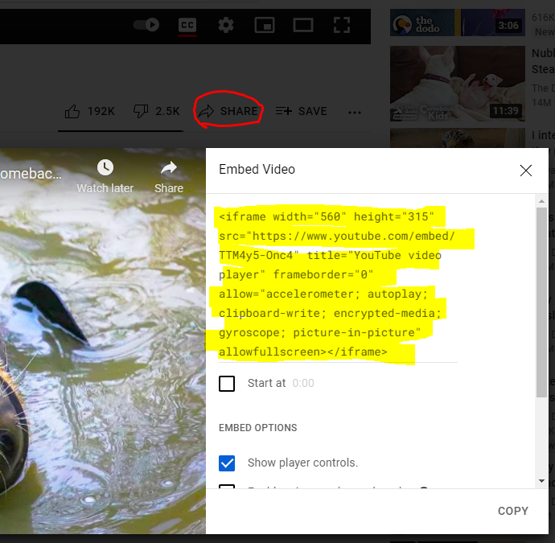
You can then paste that code into an HTML tab. Repeat for all videos you would like included.
