ASHP Mid-Year Booth Builder Office Hours 11.12.2021
We cannot copy booths over from a previous event
The deadline for making updates to your booth name closed earlier this week to give time to create graphics for the environment that lists your booth. If you would like to change your booth name, reach out to the ASHP team ASAP.

Hello - We did not realize that the deadline to add the booth staff passed on the 8th. For some reason, thought we had till the 15th to add the booth staff. Are we still able to fix this? Thanks
Yes, you can add booth staff through November 15.

Where does staff login for virtual booth?
A link to the live environment will be shared closer to the live day by the ASHP team via email.

Also, how do I add staff? I'm trying to add two residents as staff but it says they're already registered. Does that mean I don't need to add them as staff or does that mean that as staff I need to use a different email?? Thank you
I am unable to add my pharmacy resident as a staffer. It says it's a Duplicate Entry and that a person with this email address already exists.
It could be that they have already been registered in another booth, check the drop-down listing of staff. Click Staff (step 8) -> Add New Staffer. See screenshot for reference.
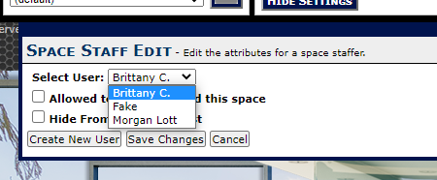
If they are not there, please submit their email addresses to the Sponsor Booth questionnaire and note which booth you are trying to add them to. The

Tried to edit staff email addresses but won't take under edit button. Tried to delete user and re-add them but it says duplicate even after I saved the deleted user
Please reach out to us via the booth questionnaire. Include the email address you used originally to staff the booth and the new email address you’d like to update them to. If you have the staffing space, you can also register them as a new user.

I had trouble adding staff. It said Duplicate and would not allow me to add anyone since they had previously participated in the residency showcase.
Staff Tutorial

Secondly, 2 of my staff members were unable to sign in. How can I resolve this issue?
First make sure they are set up as admin. Only booth staff with admin access are able to login to the Space Builder. You can add admin access by click on their name under the “Staff” tab and selecting the booth admin check box.
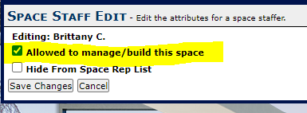
If that is set up and they still cannot login using the credentials you set up for them, reach out via the Sponsor Booth Questionnaire. Let us know their email addresses and we will reset their password. An ASHP teammember will reach out once complete.

How do our booth staffers login to edit their profiles? What is the link they can use?
Do staff members need to have their profiles updated by 11/15, or can then be done after that deadline?
This can be done during the live event, please watch the live day training for more information.

How do I enable 1:1 video chat? Thank you
This is already enabled, you can review how to use the 1:1 Chat in the live day booth training.

Do we automatically have the chat box on the lower left of booth activated? Do we have to use one of our tabs for the chat feature?
How can I tell if my chat is functional? I am asking because I want to make sure everything is functional properly before midyear.
Yes, you have to use one of your tabs for the group chat feature. The chat is not automatically enabled.
Click Tab Conent (step 7) -> Add New -> Select “Chat Room” from the drop down next to “Type” -> Select “(Add New)” next to Select Room: -> Name the chat -> Set the display order for your tab and title the tab under “Settings” -> Save Changes.
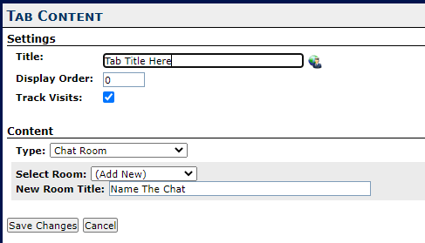

Can you share documents within the Chat function?
No, you can share attachments in a message board. See image to add attachments in a message board below:

I have uploaded a video to the Front Screen. I do not like the way it looks after the video is played - there is just an arrow on the screen. Do I need to do something to my video to make it have some sort of Thumbnail after playing the first time?
Front screen videos have a default replay image that cannot be updated.

Can you please check my Video Tab? It does not seem to be working to display the video
You have to build a video collection tab in order to share your video collection.
After uploading videos to your video collection, click Tab Content (step 7) -> Add New -> Title the tab and set the display order under settings -> select “Video Collection” in drop-down menu next to Type: -> Save Changes.

Prior to the ASHP meeting, will the links to access to the booth? I have set up people in the booth with a ID and password and want to share how they will access the booth. Thanks
Please review the live day training. ASHP will distribute the login link closer to the live day

I am not able to update the logo of our booth. I can change the logo to "Use the space name", but any time I try to upload a new logo it displays a previous logo I uploaded, not the one I am currently uploading.
We cannot figure out how to successfully delete our current front screen photo and add a new one. When we delete the current picture and upload a NEW jpeg picture, it automatically uploads the original photo that we had just deleted.
I have tried to upload a new log to the platform but the site doesn't show the new log and seem to revert to the older logo that was posted initially. I have waited about 30 minutes since upload and logged out and then in. Is there a way to correct the logo? Thanks!
This is likely a caching issue. If you clear your cache and it isn’t updating, please reach out to ASHP and include the image you would like to update to. Our team will then be able to make the update for you.

I am trying to upload the logo. It has a white background, but in the booth it shows black background with blue lettering. How do I fix that?
Our small side logo has a black background. Can this be changed? We tried to remove and re-add, and the Intrado platform is still making the background black.
This is likely because you have uploaded a logo with a transparent background. Please upload the logo you would like to use with an opaque background in the color you prefer.

How do I set up a scheduled group video chat within my booth?
How will breakout rooms work in the booth?
Do we have access to breakout rooms? I don't see the option to schedule any. Additionally, how can we test out the virtual video conferencing experience beforehand? Thanks!
Breakout rooms are not available in the booth this event. We recommend using an external link to Zoom or similar program if you’d like to include video breakouts as part of your booth experience.
I am receiving an error message when I attempt to upload videos? How can I preview videos and added documents?
Make sure the videos you are uploading are the correct file size in the file size guide. Use “Vertext” sizes more than one dimension is listed.
Is there a place visitors will be able to submit any interest in further information if someone is not in the booth at the time of the visit?
Yes, visitors will be able to post in the booth chat or message board even when the booth is not staffed.
How can we get our front screen image to not be fuzzy? Is there a specific image size that will yield better results?
Recommended dimensions/file size are available in the space builder guide.
We have a $100 visa gift certificate for a raffle prize. How do I set up for a raffle drawing? The attendee would have to leave contact info so we can do the drawing. Thanks. Denise
You have a couple of options that we think would work…
- Setting up a message board. Make it clear this information will be public.
- Provide instructions on how to send a specific booth staffer their virtual business card via an HTML tab type.
Select Tab Content (step 7) -> Add New -> Name your tab and set display order under “Settings” -> Select “HTML” in the drop-down menu next to Type: -> Click the blue “edit” link next to “HTML” to open the processor. This works like a word processor, with the option to add graphics and change fonts. -> After formatting the instructions, click “Save” -> Save Changes
Can any information within the tabs be edited after November 15th? Such as the text content we wrote in the "About Me" section? We will not be doing early commitment interviews until the week of 11/15, so would be nice to be able to include that information during Midyear, if a position is no longer available.
You will not be able to make updates to your booth after the live date. You can add posts to a message board during the live event, if you set one up. You can also link to an external site.

