ASHP Midyear Booth Office Hours 11.15.2021
We cannot copy booths over from a previous event
The deadline for making updates to your booth name closed earlier this week to give time to create graphics for the environment that lists your booth. If you would like to change your booth name, reach out to the ASHP team ASAP.
I have a video I am attempting to upload. I do not get an upload error but it also doesn’t appear to be uploaded to the space. Can I have assistance with getting it uploaded?
You have to build a video collection tab in order to share your video collection.
After uploading videos to your video collection, click Tab Content (step 7) -> Add New -> Title the tab and set the display order under settings -> select “Video Collection” in drop-down menu next to Type: -> Save Changes.
Is it possible to put a Teams link in the Chat Room to allow attendees to click on the link to join a Teams video session?
You can, but users would have to copy and paste the link into a new tab in their browser to access. You would also need to regularly re-post in the chat to keep it displayed as the chats stack on top of one another as people submit.
For a more user-friendly experience, we recommend adding the Zoom link by building an External URL Tab type. Make sure the “Open in a New Window” box is checked.
When uploading our institution logo to the space logo area, it crops it smaller than the dimensions of the space allotted for the logo, and the remainder of the space in the logo is white. The picture I am trying to use is transparent. Is this outcome a result of the transparent background? If so, how do I make the background opaque? If not, what other steps can I take to troubleshoot or fix the issue?
To get the best possible image fidelity in your booth logo space make sure that the dimensions are 200x200, the software compresses or stretches images that are of different dimensions. We also recommend using a file with an opaque background. This will need to be updated in a separate image editing software.
I am unable to add video chats because I do not have a "Scheduled Group Video Chat" tab. What is the process for adding video chats to my booth?
Video function is missing from last year. Instructions say scheduled breakout rooms should be available but the group video chat is missing. How are we supposed to video chat with applicants?
Breakout rooms are not available in the booth this event. We recommend using an external link to Zoom or similar program if you’d like to include video breakouts as part of your booth experience.
I can't change my front screen to a new picture (jpg). Why won't the picture change?
First, make sure the new file you are uploading has a unique name to the old file. If that is the case, then this is likely a caching issue. If you clear your cache and it isn’t updating, please reach out to ASHP and include the image you would like to update to. Our team will then be able to make the update for you.

I need to change resident e-mail addresses to match up with their Midyear registration addresses. How can I do that?
Please submit the email address you registered them with along with the address you’d like their account updated to via the Sponsor Booth Question form.
I get an error when clicking on the Chat Room tab. I have it selected to be a Chat within Tab Content but it does not work. Is that because we are not live or do I have it built incorrectly?
This happens when a chat tab is set up, but a chat room is not built to be housed in that tab. To add the chat room, simply go to Tab content -> Select the chat tab you have already built -> Select “(Add New)” next to Select Room: -> Name the chat -> Set the display order for your tab and title the tab under “Settings” -> Save Changes.
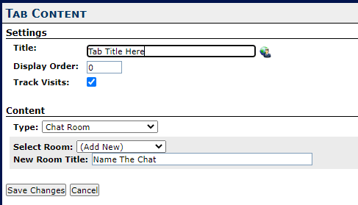
Before 11/8, I entered three other staff who will work the booth with me. Last night, I noticed the green check isn't next to staff on the left side. When I click on it, only shows my name but if I click on drop down I see the other three names. Want to be sure it's set up correctly.
If your staff are not listed in the staff tab as demonstrated in the screenshot below, they still need to be added. Select their name from the drop and click Save.
A note on the green check marks: These merely indicate you have clicked “Apply Changes” in that section of your booth, not necessarily that this section was set up properly.
One of my staff cannot log in. I have deleted her from the staff list and tried to re-enter her information (in case i made an error with password), but it will not let me do this stating her email is a duplicate entry.
Once a staff member is added, their data stays in the booth and is available to be re-staffed via the drop down. Click Staff (step 8) -> Add New Staffer. See screenshot for reference.
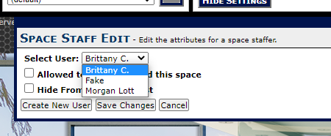
Can the message booth be edited daily during the live event?
Message boards and chats can be updated by posting new content during the live event. All other booth elements are not available to be updated during the live event.

